

You now have access!
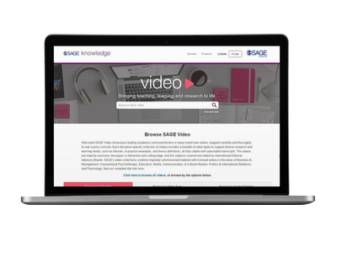
Your library at INSTITUTION now subscribes to SAGE Video—cutting-edge teaching and research-oriented video material curated to support students of all levels.
Get started today >>
Use SAGE Video to study and expand your learning
SAGE Video offers an up-close, interactive view into the most critical concepts within a discipline. With SAGE Video, you can:
- Access clips from leading experts, real-world scenarios, how-to guides, conference presentation excerpts, tutorials, interviews, and more to expand on what you are learning in the classroom, or discover a new topic on your schedule.
- Cite scholarly videos as references in research projects, papers, and presentations.
- Support your research and learning with expertly curated video content that is fully citable, and includes downloadable transcripts.
 | Watch the video overview |  | Browse the platform |  | View the complete title list



