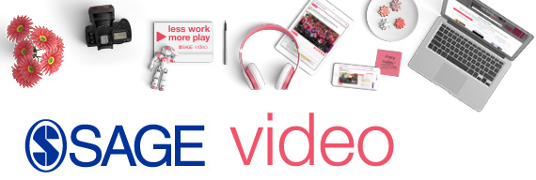

You have access!
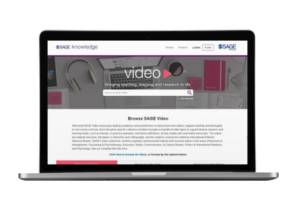
“So much important information explained in an understandable way.... An excellent addition to my source of videos”
– Bill Howe, Connecticut Department of Education

Your library at INSTITUTION now subscribes to the SAGE Video—cutting-edge teaching and research-oriented video material curated to support students of all levels.
Get started today >>
SAGE Video has been developed in partnership with leading academics, societies and practitioners, including many of SAGE’s own authors and academic partners and offers an up-close, interactive view into the most critical concepts within a discipline. With SAGE Video, you can:
- Access clips from leading experts, real-world scenarios, how-to guides, conference presentation excerpts, tutorials, interviews, and more
- Embed video content into your course management system for use in lectures and tutorials
- Support your research and teaching with expertly curated video content that is fully citable, and includes downloadable transcripts
 | Watch the video overview |  | Browse the platform |  | View the complete title list



